|  |
| --- |
| Assignment 4 |
| Selenium Testing |
| Belo, Lea Monica M.  7638471 |
|  |
|  |

# Part 1 – Decision Table

## Initial Decision Table

|  |  |  |  |  |  |  |
| --- | --- | --- | --- | --- | --- | --- |
| **Initial Decision Table** | | | | | | |
|  | **R1** | **R2** | **R3** | **R4** | **R5** | **R6** |
| **C1: Accidents** | Less than 3 | Greater than 3 | Less than 3 | Greater than 3 | Less than 3 | Greater than 3 |
| **C2: Driving Experience** | 0 | 0 | 1 to 9 years | 1 to 9 years | Greater than 9 years | Greater than 9 years |
| **C3: Age** | 30 or older | 30 or older | 30 or older | 30 or older | 30 or older | 30 or older |
| **Provide Insurance** | X |  | X |  | X |  |
| **Base Rate** |  |  |  |  |  |  |
| $2,000.00 | X | X |  |  |  |  |
| $1,000.00 |  |  | X | X |  |  |
| $500.00 |  |  |  |  | X | X |
| **Rate Reduction** |  |  |  |  |  |  |
| 15% |  |  | X | X | X | X |

|  |  |  |  |  |  |  |
| --- | --- | --- | --- | --- | --- | --- |
| **Initial Decision Table (continued..)** | | | | | | |
|  | **R7** | **R8** | **R9** | **R10** | **R11** | **R12** |
| **C1: Accidents** | Less than 3 | Greater than 3 | Less than 3 | Greater than 3 | Less than 3 | Greater than 3 |
| **C2: Driving Experience** | 0 | 0 | 1 to 9 years | 1 to 9 years | Greater than 9 years | Greater than 9 years |
| **C3: Age** | younger than 30 | younger than 30 | younger than 30 | younger than 30 | younger than 30 | younger than 30 |
| **Provide Insurance** | X |  | X |  | X |  |
| **Base Rate** |  |  |  |  |  |  |
| $2,000.00 | X | X |  |  |  |  |
| $1,000.00 |  |  | X | X |  |  |
| $500.00 |  |  |  |  | X | X |
| **Rate Reduction** |  |  |  |  |  |  |
| 15% |  |  |  |  |  |  |

## Second Decision Table

|  |  |  |  |  |  |  |
| --- | --- | --- | --- | --- | --- | --- |
| **Second Decision Table** | | | | | | |
|  | **R1** | **R3** | **R5** | **R7** | **R9** | **R11** |
| **C1: Accidents** | Less than 3 | Less than 3 | Less than 3 | Less than 3 | Less than 3 | Less than 3 |
| **C2: Driving Experience** | 0 | 1 to 9 years | Greater than 9 years | 0 | 1 to 9 years | Greater than 9 years |
| **C3: Age** | 30 or older | 30 or older | 30 or older | Younger than 30 | Younger than 30 | Younger than 30 |
| **Provide Insurance** | X | X | X | X | X | X |
| **Base Rate** |  |  |  |  |  |  |
| $2,000.00 | X |  |  | X |  |  |
| $1,000.00 |  | X |  |  | X |  |
| $500.00 |  |  | X |  |  | X |
| **Rate Reduction** |  |  |  |  |  |  |
| 15% |  | X | X |  |  |  |

### Removed Don’t Cares:

|  |  |  |  |  |  |  |
| --- | --- | --- | --- | --- | --- | --- |
| **Removed Cases:** | | | | | | |
|  | **R2** | **R4** | **R6** | **R8** | **R10** | **R12** |
| **C1: Accidents** | Greater than 3 | Greater than 3 | Greater than 3 | Greater than 3 | Greater than 3 | Greater than 3 |
| **C2: Driving Experience** | 0 | 1 to 9 years | Greater than 9 years | 0 | 1 to 9 years | Greater than 9 years |
| **C3: Age** | 30 or older | 30 or older | 30 or older | Younger than 30 | Younger than 30 | Younger than 30 |
| **Provide Insurance** |  |  |  |  |  |  |
| **Base Rate** |  |  |  |  |  |  |
| $2,000.00 | X |  |  | X |  |  |
| $1,000.00 |  | X |  |  | X |  |
| $500.00 |  |  | X |  |  | X |
| **Rate Reduction** |  |  |  |  |  |  |
| 15% |  | X | X |  |  |  |

## Final Decision Table

|  |  |  |  |  |  |
| --- | --- | --- | --- | --- | --- |
| **Final Decision Table** | | | | | |
|  | **R1 & R7** | **R3** | **R5** | **R9** | **R11** |
| **C1: Accidents** | Less than 3 | Less than 3 | Less than 3 | Less than 3 | Less than 3 |
| **C2: Driving Experience** | 0 | 1 to 9 years | Greater than 9 years | 1 to 9 years | Greater than 9 years |
| **C3: Age** | Any age | 30 or older | 30 or older | Younger than 30 | Younger than 30 |
| **Provide Insurance** | X | X | X | X | X |
| **Base Rate** |  |  |  |  |  |
| $2,000.00 | X |  |  | X |  |
| $1,000.00 |  | X |  |  | X |
| $500.00 |  |  | X |  |  |
| **Rate Reduction** |  |  |  |  |  |
| 15% |  | X | X |  |  |

Test Cases

* R1 & R7
  + Statement: Person provided by an insurance, with less than 3 accidents, no driving experience and any age.
  + Expected Result: Base Rate is $2,000.00
* R3
  + Statement: Person provided by an insurance, with less than 3 accidents, 1 to 9 years of driving experience and is 30 years of age or older.
  + Expected Result: Base Rate is $1,000.00 with 15% Rate Reduction
* R5
  + Statement: Person provided by an insurance, with less than 3 accidents, greater than 9 years of driving experience and is 30 years of age or older.
  + Expected Result: Base Rate is $500.00 with 15% Rate Reduction
* R9
  + Statement: Person provided by an insurance, with less than 3 accidents, 1 to 9 years of driving experience and is younger than 30 years old
  + Expected Result: Base Rate is $1,500.00
* R11
  + Statement: Person provided by an insurance, with less than 3 accidents, greater than 9 years of driving experience and is younger than 30 years old
  + Expected Result: Base Rate is $1,000.00

# Part 2

## Screenshots:

## Main

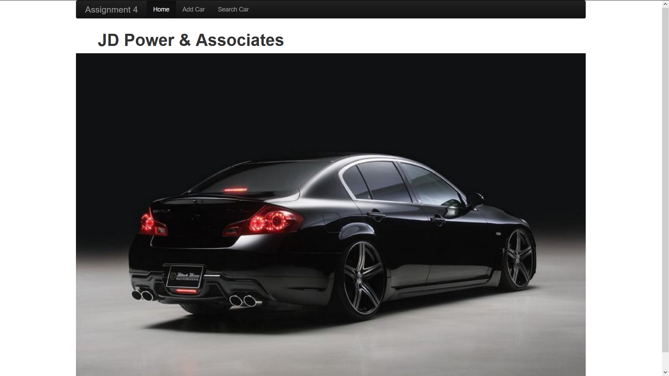

## Add Car

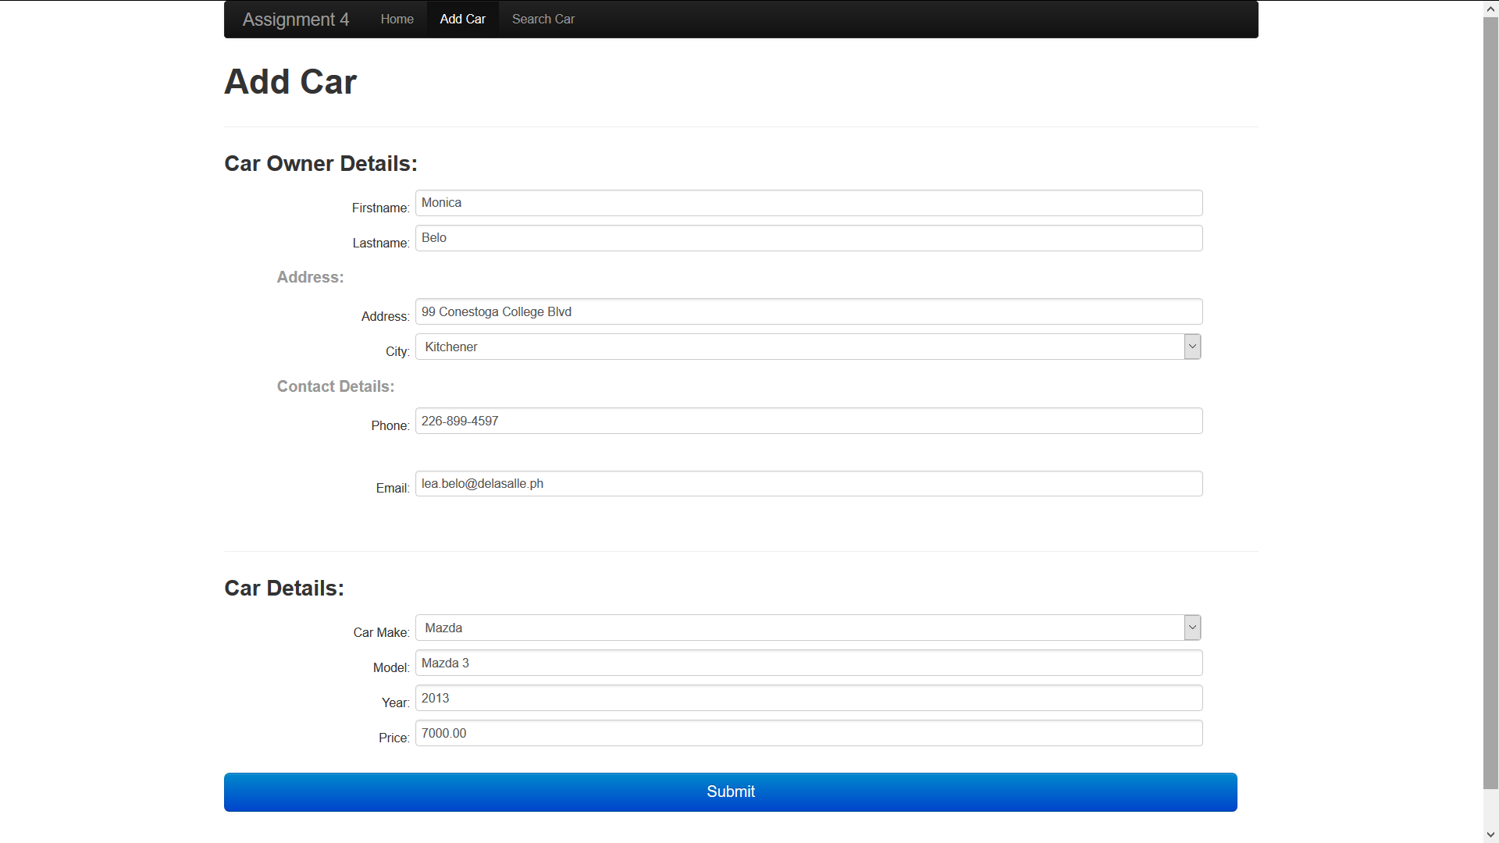

## Details shown after adding car

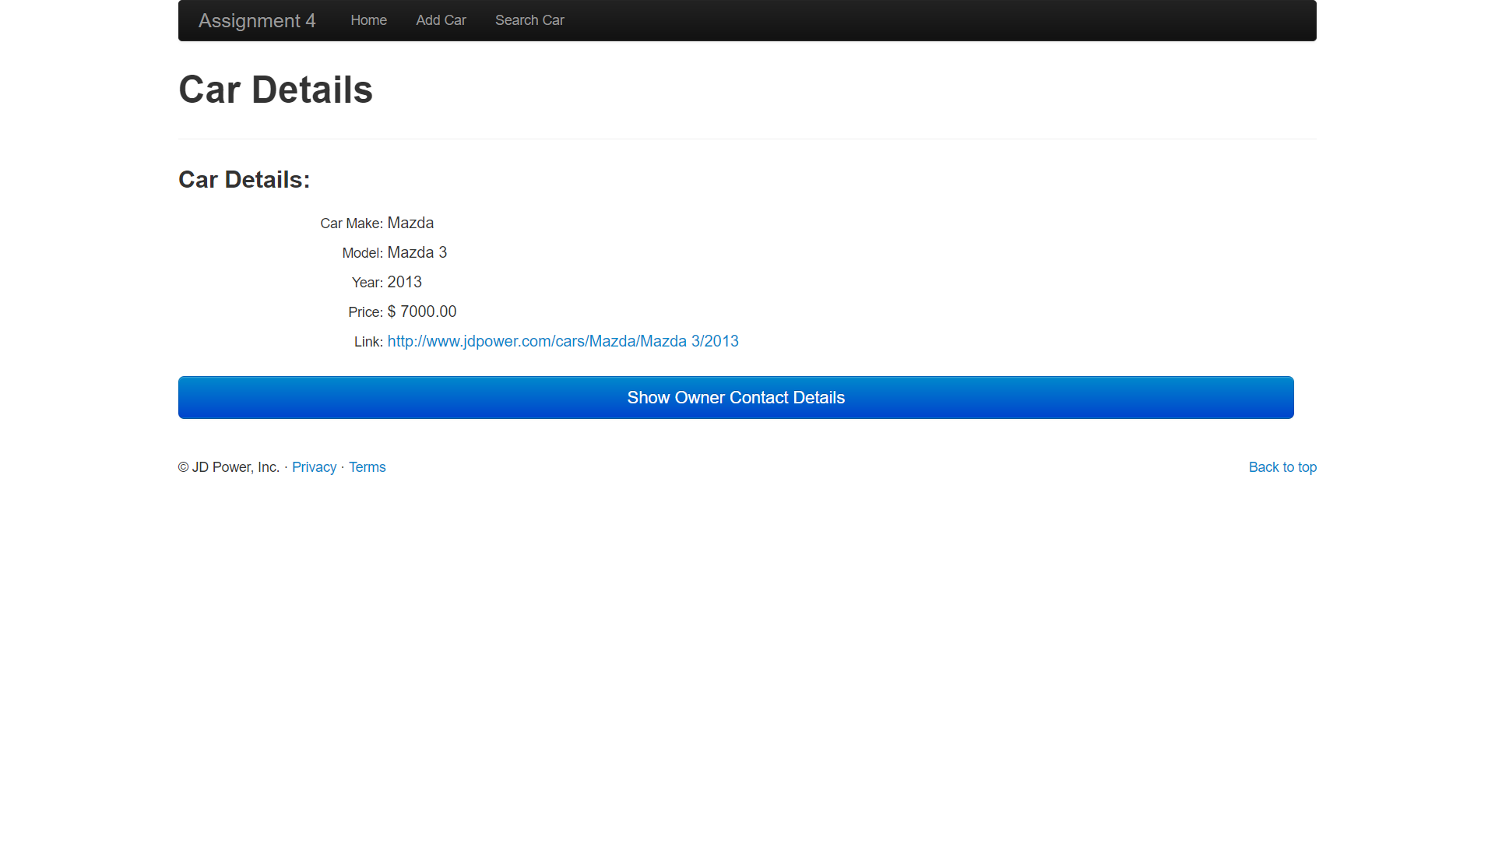

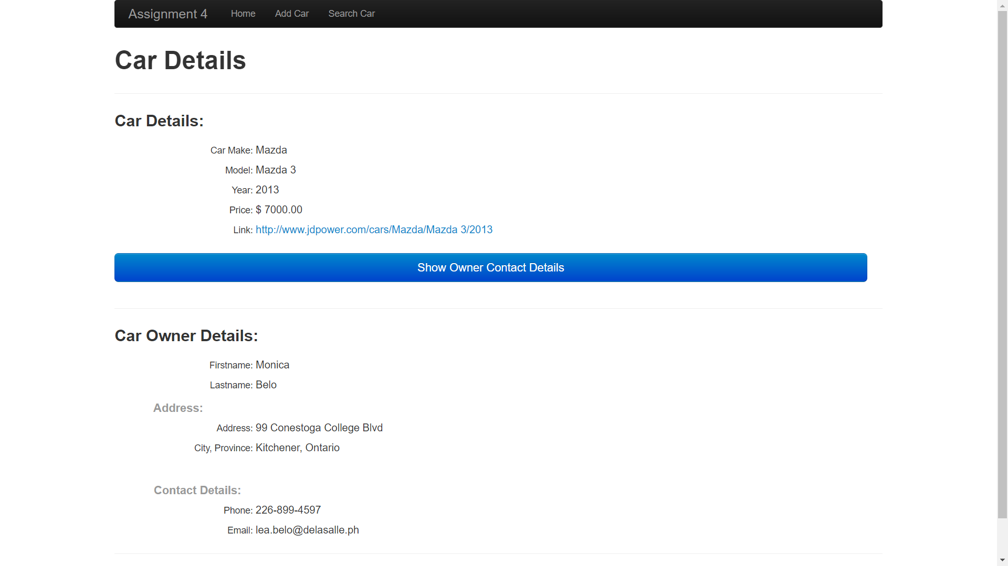

## Search Car

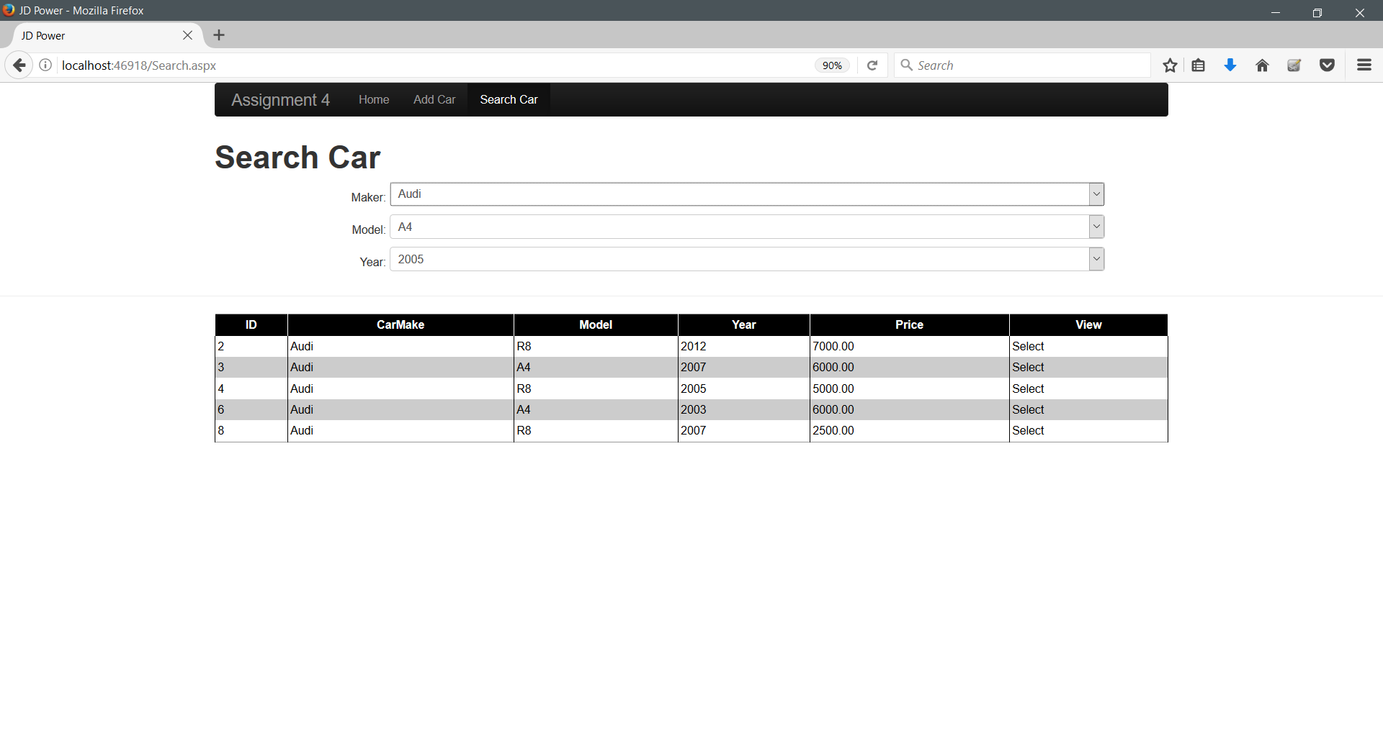

## 

## Selected Car

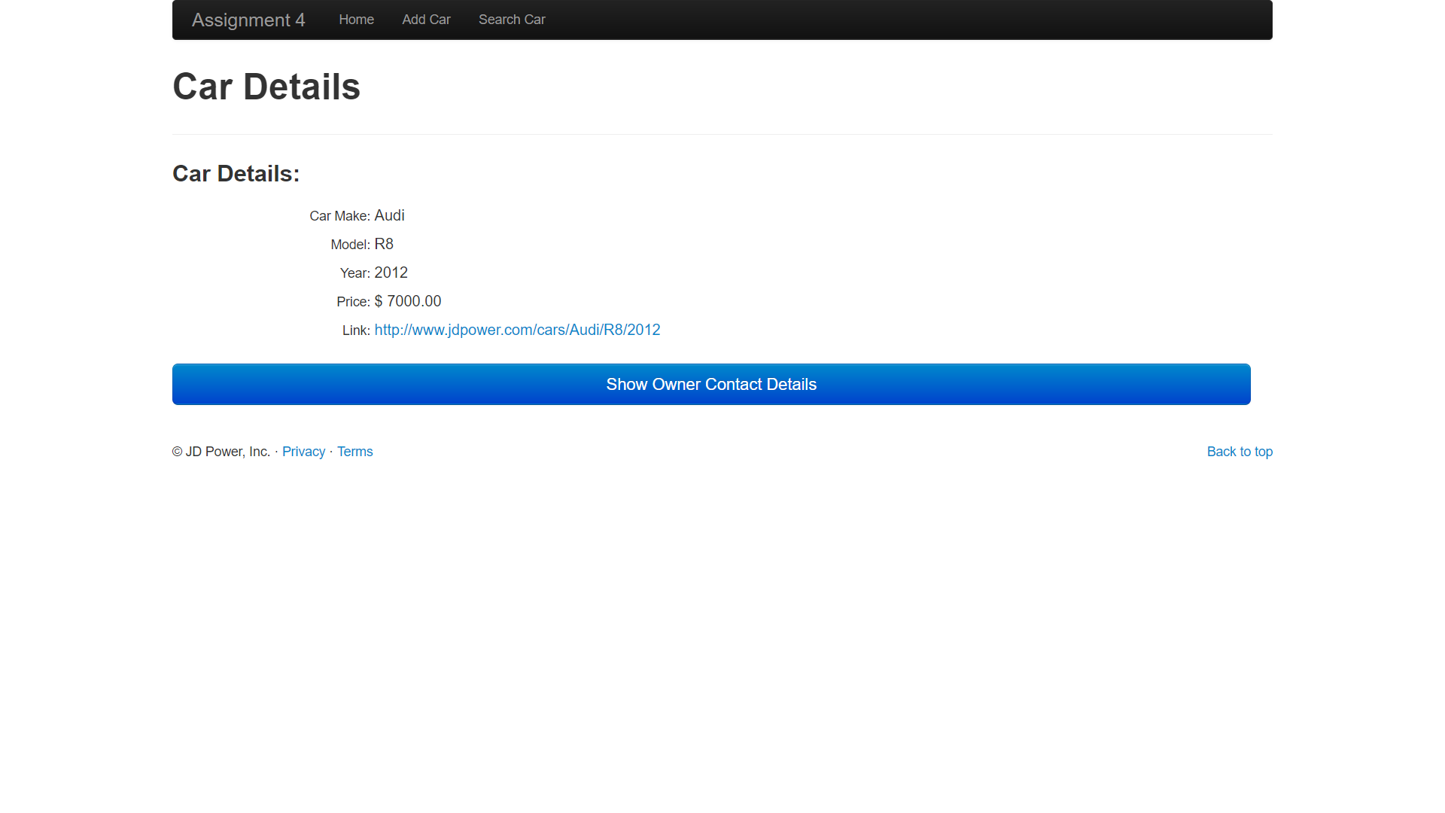 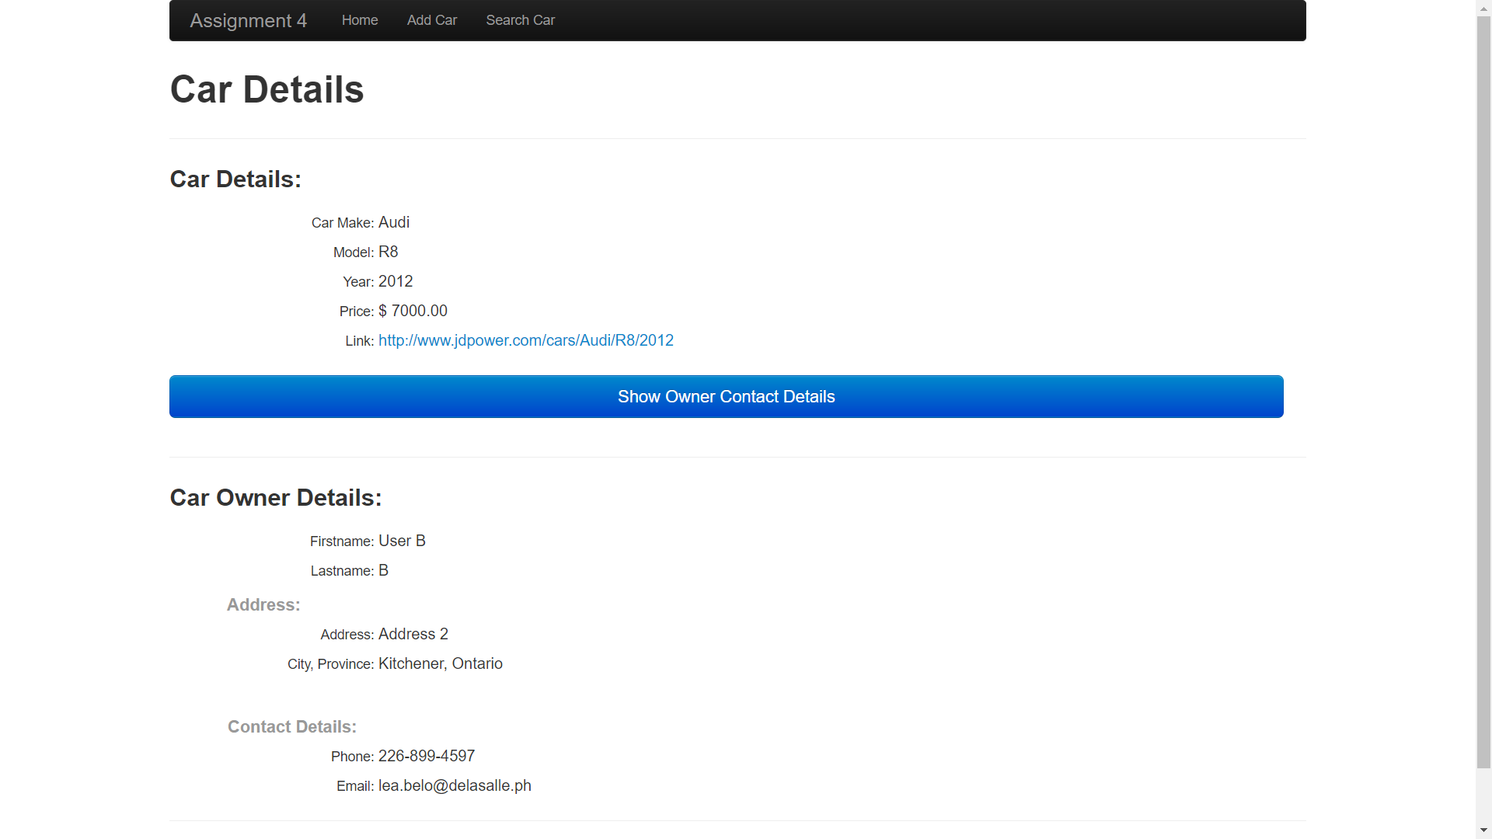

## Selenium Generated Test:

using System;

using System.Text;

using System.Text.RegularExpressions;

using System.Threading;

using NUnit.Framework;

using OpenQA.Selenium;

using OpenQA.Selenium.Firefox;

using OpenQA.Selenium.Support.UI;

namespace SeleniumTests

{

[TestFixture]

public class BestCase

{

private IWebDriver driver;

private StringBuilder verificationErrors;

private string baseURL;

private bool acceptNextAlert = true;

[SetUp]

public void SetupTest()

{

driver = new FirefoxDriver();

baseURL = "http://localhost:46918/";

verificationErrors = new StringBuilder();

}

[TearDown]

public void TeardownTest()

{

try

{

driver.Quit();

}

catch (Exception)

{

// Ignore errors if unable to close the browser

}

Assert.AreEqual("", verificationErrors.ToString());

}

[Test]

public void TheBestCaseTest()

{

driver.Navigate().GoToUrl(baseURL + "/Index.aspx");

driver.FindElement(By.LinkText("Add Car")).Click();

driver.FindElement(By.Id("submit")).Click();

driver.FindElement(By.Id("fname")).Clear();

driver.FindElement(By.Id("fname")).SendKeys("Fname");

driver.FindElement(By.Id("lname")).Clear();

driver.FindElement(By.Id("lname")).SendKeys("Lname");

driver.FindElement(By.Id("submit")).Click();

driver.FindElement(By.Id("address")).Clear();

driver.FindElement(By.Id("address")).SendKeys("Address 1");

new SelectElement(driver.FindElement(By.Id("city"))).SelectByText("Kitchener");

driver.FindElement(By.Id("submit")).Click();

driver.FindElement(By.Id("phone")).Clear();

driver.FindElement(By.Id("phone")).SendKeys("226-899-4597");

driver.FindElement(By.Id("submit")).Click();

driver.FindElement(By.Id("email")).Clear();

driver.FindElement(By.Id("email")).SendKeys("lea.belo@delasalle.ph");

new SelectElement(driver.FindElement(By.Id("carmake"))).SelectByText("Mazda");

driver.FindElement(By.Id("model")).Clear();

driver.FindElement(By.Id("model")).SendKeys("Mazda 3");

driver.FindElement(By.Id("year")).Clear();

driver.FindElement(By.Id("year")).SendKeys("2009");

driver.FindElement(By.Id("price")).Clear();

driver.FindElement(By.Id("price")).SendKeys("6000");

driver.FindElement(By.Id("submit")).Click();

driver.FindElement(By.Id("submit")).Click();

}

private bool IsElementPresent(By by)

{

try

{

driver.FindElement(by);

return true;

}

catch (NoSuchElementException)

{

return false;

}

}

private bool IsAlertPresent()

{

try

{

driver.SwitchTo().Alert();

return true;

}

catch (NoAlertPresentException)

{

return false;

}

}

private string CloseAlertAndGetItsText() {

try {

IAlert alert = driver.SwitchTo().Alert();

string alertText = alert.Text;

if (acceptNextAlert) {

alert.Accept();

} else {

alert.Dismiss();

}

return alertText;

} finally {

acceptNextAlert = true;

}

}

}

}

## C# Test:

using System;

using System.Text;

using System.Text.RegularExpressions;

using System.Threading;

using NUnit.Framework;

using OpenQA.Selenium;

using OpenQA.Selenium.Firefox;

using OpenQA.Selenium.Support.UI;

namespace SeleniumTests

{

[TestFixture]

public class TestCase

{

private IWebDriver driver;

private StringBuilder verificationErrors;

private string baseURL;

private bool acceptNextAlert = true;

[SetUp]

public void SetupTest()

{

driver = new FirefoxDriver();

baseURL = "http://localhost:46918/";

verificationErrors = new StringBuilder();

}

[TearDown]

public void TeardownTest()

{

try

{

driver.Quit();

}

catch (Exception)

{

// Ignore errors if unable to close the browser

}

Assert.AreEqual("", verificationErrors.ToString());

}

[Test]

public void NameTest()

{

driver.Navigate().GoToUrl(baseURL + "/AddCar.aspx");

driver.FindElement(By.Id("fname")).SendKeys("");

driver.FindElement(By.Id("lname")).SendKeys("");

driver.FindElement(By.Id("submit")).Click();

string nameTest = driver.FindElement(By.Id("lblemptyField")).Text;

Assert.AreEqual("Please Enter Firstname and Lastname.", nameTest);

}

[Test]

public void AddressBlankTest()

{

driver.Navigate().GoToUrl(baseURL + "/AddCar.aspx");

driver.FindElement(By.Id("address")).SendKeys("");

driver.FindElement(By.Id("submit")).Click();

string addresstest = driver.FindElement(By.Id("lblemptyFieldAddress")).Text;

Assert.AreEqual("Please Enter Address.", addresstest);

}

[Test]

public void CarDetailsBlankTest()

{

driver.Navigate().GoToUrl(baseURL + "/AddCar.aspx");

driver.FindElement(By.Id("model")).SendKeys("");

driver.FindElement(By.Id("year")).SendKeys("");

driver.FindElement(By.Id("price")).SendKeys("");

driver.FindElement(By.Id("submit")).Click();

string cardetails = driver.FindElement(By.Id("lblemptyFieldCar")).Text;

Assert.AreEqual("Please Enter Complete Car Details.", cardetails);

}

[Test]

[TestCase("@com")]

[TestCase("1@a")]

[TestCase(".com")]

public void TheEmaiLTest(string email)

{

driver.Navigate().GoToUrl(baseURL + "/AddCar.aspx");

WebDriverWait wait = new WebDriverWait(driver, TimeSpan.FromSeconds(10));

//driver.FindElement(By.XPath("/html/body/div[@class='container marketing']/form[@id='ctl01']/div[@class='featurette'][1]/div[@class='lead']/input[@id='email']")).SendKeys(email);

driver.FindElement(By.Id("email")).SendKeys(email);

driver.FindElement(By.Id("phone")).Click();

//string emailTest = driver.FindElement(By.XPath("/html/body/div[@class='container marketing']/form[@id='ctl01']/div[@class='featurette'][1]/div[@class='lead']/span[@id='RegularExpressionValidator1']")).Text;

string emailTest = driver.FindElement(By.Id("RegularExpressionValidator1")).Text;

Assert.AreEqual("Invalid Email.", emailTest);

}

[Test]

[TestCase("1")]

[TestCase("22694597")]

[TestCase("(1234567891)")]

public void PhoneTest(string phone)

{

driver.Navigate().GoToUrl(baseURL + "/AddCar.aspx");

driver.FindElement(By.XPath("/html/body/div[@class='container marketing']/form[@id='ctl01']/div[@class='featurette'][1]/div[@class='lead']/input[@id='phone']")).SendKeys(phone);

driver.FindElement(By.Id("email")).Click();

string emailTest = driver.FindElement(By.Id("regexpName")).Text;

//string emailTest = driver.FindElement(By.XPath("/html/body/div[@class='container marketing']/form[@id='ctl01']/div[@class='featurette'][1]/div[@class='lead']/span[@id='regexpName']")).Text;

Assert.AreEqual("Invalid Phone number.", emailTest);

}

private bool IsElementPresent(By by)

{

try

{

driver.FindElement(by);

return true;

}

catch (NoSuchElementException)

{

return false;

}

}

private bool IsAlertPresent()

{

try

{

driver.SwitchTo().Alert();

return true;

}

catch (NoAlertPresentException)

{

return false;

}

}

private string CloseAlertAndGetItsText()

{

try

{

IAlert alert = driver.SwitchTo().Alert();

string alertText = alert.Text;

if (acceptNextAlert)

{

alert.Accept();

}

else

{

alert.Dismiss();

}

return alertText;

}

finally

{

acceptNextAlert = true;

}

}

}

}

## Codes:

### Index.aspx

<%@ Page Language="C#" AutoEventWireup="true" CodeBehind="Index.aspx.cs" Inherits="Assign4.Index" %>

<!DOCTYPE html>

<html xmlns="http://www.w3.org/1999/xhtml">

<head runat="server">

<meta charset="UTF-8">

<title>JD Power</title>

<meta name="viewport" content="width=device-width, initial-scale=1.0">

<meta name="description" content="">

<meta name="author" content="">

<link href="css/bootstrap.css" rel="stylesheet" type="text/css"/>

<link href="css/responsive.css" rel="stylesheet" type="text/css"/>

<link href="styles_main.css" rel="stylesheet" type="text/css"/>

<link rel="apple-touch-icon-precomposed" sizes="144x144" href="favicon/android-icon-144x144.png">

<link rel="apple-touch-icon-precomposed" sizes="96x96" href=".favicon/android-icon-96x96.png">

<link rel="apple-touch-icon-precomposed" sizes="72x72" href="favicon/android-icon-72x72.png">

<link rel="apple-touch-icon-precomposed" href="favicon/android-icon-48x48.png">

<link rel="shortcut icon" href="favicon/favicon.png">

</head>

<body>

<!-- NAVBAR

================================================== -->

<div class="navbar-wrapper">

<!-- Wrap the .navbar in .container to center it within the absolutely positioned parent. -->

<div class="container">

<div class="navbar navbar-inverse">

<div class="navbar-inner">

<!-- Responsive Navbar Part 1: Button for triggering responsive navbar (not covered in tutorial). Include responsive CSS to utilize. -->

<button type="button" class="btn btn-navbar" data-toggle="collapse" data-target=".nav-collapse">

<span class="icon-bar"></span>

<span class="icon-bar"></span>

<span class="icon-bar"></span>

</button>

<a class="brand" href="#">Assignment 4</a>

<!-- Responsive Navbar Part 2: Place all navbar contents you want collapsed withing .navbar-collapse.collapse. -->

<div class="nav-collapse collapse">

<ul class="nav">

<li class="active"><a href="Index.aspx">Home</a></li>

<li><a href="AddCar.aspx">Add Car</a></li>

<li><a href="Search.aspx">Search Car</a></li>

<!-- Read about Bootstrap dropdowns at http://twitter.github.com/bootstrap/javascript.html#dropdowns -->

</ul>

</div><!--/.nav-collapse -->

</div><!-- /.navbar-inner -->

</div><!-- /.navbar -->

</div> <!-- /.container -->

</div><!-- /.navbar-wrapper -->

<div class="jumbotron jumbotron-fluid">

<div class="container">

<h1 class="display-3" style="margin-left:50px;">JD Power & Associates</h1>

<div style="width:100%">

<asp:Image ID="Image1" runat="server" ImageUrl="~/9VTkqmo.jpg" />

</div>

</div>

</div>

<script src="js/jquery.js" type="text/javascript"></script>

<script src="js/transition.js" type="text/javascript"></script>

<script src="js/alert.js" type="text/javascript"></script>

<script src="js/modal.js" type="text/javascript"></script>

<script src="js/dropdown.js" type="text/javascript"></script>

<script src="js/scrollspy.js" type="text/javascript"></script>

<script src="js/tab.js" type="text/javascript"></script>

<script src="js/tooltip.js" type="text/javascript"></script>

<script src="js/popover.js" type="text/javascript"></script>

<script src="js/button.js" type="text/javascript"></script>

<script src="js/collapse.js" type="text/javascript"></script>

<script src="js/carousel.js" type="text/javascript"></script>

<script src="js/typeahead.js" type="text/javascript"></script>

<script>

!function ($) {

$(function(){

// carousel demo

$('#myCarousel').carousel();

});

}(window.jQuery);

</script>

<script src="js/holder.js" type="text/javascript"></script>

</body>

</html>

### Index.aspx.cs

using System;

using System.Collections.Generic;

using System.Linq;

using System.Web;

using System.Web.UI;

using System.Web.UI.WebControls;

namespace Assign4

{

public partial class Index : System.Web.UI.Page

{

protected void Page_Load(object sender, EventArgs e)

{

}

}

}

### AddCar.aspx

<%@ Page Language="C#" AutoEventWireup="true" CodeBehind="AddCar.aspx.cs" Inherits="Assign4.AddCar" %>

<!DOCTYPE html>

<html xmlns="http://www.w3.org/1999/xhtml">

<head runat="server">

<meta charset="UTF-8">

<title>JD Power</title>

<meta name="viewport" content="width=device-width, initial-scale=1.0">

<meta name="description" content="">

<meta name="author" content="">

<link href="css/bootstrap.css" rel="stylesheet" type="text/css"/>

<link href="css/responsive.css" rel="stylesheet" type="text/css"/>

<link href="styles_main.css" rel="stylesheet" type="text/css"/>

<link rel="apple-touch-icon-precomposed" sizes="144x144" href="favicon/android-icon-144x144.png">

<link rel="apple-touch-icon-precomposed" sizes="96x96" href=".favicon/android-icon-96x96.png">

<link rel="apple-touch-icon-precomposed" sizes="72x72" href="favicon/android-icon-72x72.png">

<link rel="apple-touch-icon-precomposed" href="favicon/android-icon-48x48.png">

<link rel="shortcut icon" href="favicon/favicon.png">

</head>

<body>

<!-- NAVBAR

================================================== -->

<div class="navbar-wrapper">

<!-- Wrap the .navbar in .container to center it within the absolutely positioned parent. -->

<div class="container">

<div class="navbar navbar-inverse">

<div class="navbar-inner">

<!-- Responsive Navbar Part 1: Button for triggering responsive navbar (not covered in tutorial). Include responsive CSS to utilize. -->

<button type="button" class="btn btn-navbar" data-toggle="collapse" data-target=".nav-collapse">

<span class="icon-bar"></span>

<span class="icon-bar"></span>

<span class="icon-bar"></span>

</button>

<a class="brand" href="Index.aspx">Assignment 4</a>

<!-- Responsive Navbar Part 2: Place all navbar contents you want collapsed withing .navbar-collapse.collapse. -->

<div class="nav-collapse collapse">

<ul class="nav">

<li><a href="Index.aspx">Home</a></li>

<li class="active"><a href="AddCar.aspx">Add Car</a></li>

<li><a href="Search.aspx">Search Car</a></li>

<!-- Read about Bootstrap dropdowns at http://twitter.github.com/bootstrap/javascript.html#dropdowns -->

</ul>

</div><!--/.nav-collapse -->

</div><!-- /.navbar-inner -->

</div><!-- /.navbar -->

</div> <!-- /.container -->

</div><!-- /.navbar-wrapper -->

<div class="jumbotron jumbotron-fluid">

<div class="container">

<h1 class="display-3">Add Car</h1>

</div>

</div>

<div class="container marketing">

<form runat="server">

<hr class="featurette-divider">

<div class="featurette">

<h3 class="featurette-heading">Car Owner Details:</h3>

<label class="sr-only" Visible="false" style="display: inline-block; color:red; font-weight:bold;" id="lblemptyField"> </label><br />

<label class="sr-only" Visible="false" style="display: inline-block; color:red; font-weight:bold;" id="lblemptyFieldAddress"> </label><br />

<label class="sr-only" Visible="false" style="display: inline-block; color:red; font-weight:bold;" id="lblemptyFieldCar"> </label>

<div class="lead" style="margin-bottom:0px;">

<label for="fname" class="sr-only" style="display: inline-block; width:18%; text-align: right;">Firstname: </label>

<asp:TextBox runat="server" type="text" name="fname" id="fname" class="form-control" placeholder="Firstname" required autofocus style="width: 75%">

</asp:TextBox>

<br>

<label for="lname" class="sr-only" style="display: inline-block; width:18%; text-align: right;">Lastname: </label>

<asp:TextBox runat="server" type="text" name="lname" id="lname" class="form-control" placeholder="Lastname" required style="width: 75%">

</asp:TextBox>

<br />

<h4 class="sr-only" style="display: inline-block; width:18%; display: inline-block; text-align:left;

margin-bottom:0px; margin-left:50px;">

<span class="muted">&nbsp;&nbsp;Address:</span></label>

<h4 style="width: 75%"></h4>

<label for="address" class="sr-only" style="display: inline-block; width:18%; text-align: right;">Address: </label>

<asp:TextBox runat="server" type="text" name="address" id="address" class="form-control" placeholder="Address" required style="width: 75%">

</asp:TextBox>

<br />

<label for="city" class="sr-only" style="display: inline-block; width:18%; text-align: right;">City: </label>

<asp:DropDownList class="form-control input-lg" name="city" id="city" required style="width: 76%"

runat="server" DataSourceID="SqlDataSource1" DataTextField="City" DataValueField="City">

</asp:DropDownList>

<asp:SqlDataSource ID="SqlDataSource1" runat="server" ConnectionString="<%$ ConnectionStrings:JDCarsConnectionString %>" SelectCommand="SELECT [City] FROM [City]"></asp:SqlDataSource>

<asp:LinqDataSource ID="LinqDataSource2" runat="server" EntityTypeName="">

</asp:LinqDataSource>

<h4 class="sr-only" style="display: inline-block; width:18%; display: inline-block; text-align:left;

margin-bottom:0px; margin-left:50px;">

<span class="muted">&nbsp;&nbsp;Contact Details:</span></label>

<h4 style="width: 75%"></h4>

<label for="phone" class="sr-only" style="display: inline-block; width:18%; text-align: right;">

Phone: </label>

<asp:TextBox runat="server" type="text" name="phone" id="phone" class="form-control" placeholder="123-123-1234 or (123)123-1234" required style="width: 75%">

</asp:TextBox>

<br />

<asp:RegularExpressionValidator ID="regexpName" runat="server" style=" font-size:medium; margin-left:20%"

ErrorMessage="Invalid Phone number."

ControlToValidate="phone"

ValidationExpression="^(\+0?1\s)?\(?\d{3}\)?[\s.-]\d{3}[\s.-]\d{4}$" />

<br/>

<label for="inputEmail" class="sr-only" style="display: inline-block; width:18%; text-align: right;">

Email: </label>

<asp:TextBox runat="server" type="email" id="email" name="email" class="form-control" placeholder="youremail@email.com" required style="width: 75%">

</asp:TextBox>

<asp:RegularExpressionValidator ID="RegularExpressionValidator1" runat="server" style=" font-size:medium; margin-left:20%"

ErrorMessage="Invalid Email."

ControlToValidate="email"

ValidationExpression="^\w+[\w-\.]*\@\w+((-\w+)|(\w*))\.[a-z]{2,3}$" />

</div>

</div>

<hr class="featurette-divider">

<div class="featurette">

<h3 class="featurette-heading">Car Details:</h3>

<p class="lead">

<label for="carmake" class="sr-only" style="display: inline-block; width:18%; text-align: right;">Car Make: </label>

<asp:DropDownList class="form-control input-lg" name="carmake" id="carmake" required style="width: 76%"

runat="server" DataSourceID="SqlDataSource2" DataTextField="Manufacturer" DataValueField="Manufacturer">

</asp:DropDownList>

<asp:SqlDataSource ID="SqlDataSource2" runat="server"

ConnectionString="<%$ ConnectionStrings:JDCarsConnectionString %>"

SelectCommand="SELECT [Manufacturer] FROM [CarMake]"></asp:SqlDataSource>

<label for="model" class="sr-only" style="display: inline-block; width:18%; text-align: right;">Model: </label>

<asp:TextBox runat="server" type="text" name="model" id="model" class="form-control" placeholder="R8" required style="width: 75%">

</asp:TextBox>

<br />

<label for="year" class="sr-only" style="display: inline-block; width:18%; text-align: right;">Year: </label>

<asp:TextBox runat="server" type="text" name="year" id="year" class="form-control" placeholder="2012" required style="width: 75%">

</asp:TextBox>

<br />

<label for="price" class="sr-only" style="display: inline-block; width:18%; text-align: right;">Price: </label>

<asp:TextBox runat="server" type="text" name="price" id="price" class="form-control" placeholder="$5,000.00" required style="width: 75%">

</asp:TextBox>

<br />

</p>

<asp:Button ID="submit" runat="server" Text="Submit" OnClientClick="Validate();"

class="btn btn-large btn-primary btn-block" style="width: 98%" OnClick="submit_Click"/>

<br />

</div>

<br />

<footer>

<p class="pull-right"><a href="#">Back to top</a></p>

<p>&copy; JD Power, Inc. &middot; <a href="#">Privacy</a> &middot; <a href="#">Terms</a></p>

</footer>

</form>

</div>

<script src="js/jquery.js" type="text/javascript"></script>

<script src="js/transition.js" type="text/javascript"></script>

<script src="js/alert.js" type="text/javascript"></script>

<script src="js/modal.js" type="text/javascript"></script>

<script src="js/dropdown.js" type="text/javascript"></script>

<script src="js/scrollspy.js" type="text/javascript"></script>

<script src="js/tab.js" type="text/javascript"></script>

<script src="js/tooltip.js" type="text/javascript"></script>

<script src="js/popover.js" type="text/javascript"></script>

<script src="js/button.js" type="text/javascript"></script>

<script src="js/collapse.js" type="text/javascript"></script>

<script src="js/carousel.js" type="text/javascript"></script>

<script src="js/typeahead.js" type="text/javascript"></script>

<script>

!function ($) {

$(function(){

// carousel demo

$('#myCarousel').carousel();

});

}(window.jQuery);

</script>

<script>

var emptyLabel = document.getElementById("lblemptyField");

var emptyLabelAddress = document.getElementById("lblemptyFieldAddress");

var emptyLabelCar = document.getElementById("lblemptyFieldCar");

function Validate()

{

NameValidation();

AddressValidation();

CarDetailsValidation();

}

function NameValidation()

{

var fname_item;

var fnameVal = document.getElementById("<%=fname.ClientID %>");

var lname_item;

var lnameVal = document.getElementById("<%=lname.ClientID %>");

lname_item = lnameVal.value;

fname_item = fnameVal.value;

if (fname_item == "" && lname_item == "")

{

lblemptyField.innerHTML = "Please Enter Firstname and Lastname.";

}

else if (fname_item == "")

{

lblemptyField.innerHTML ="Please Enter Lastname.";

}

else if (fname_item == "")

{

lblemptyField.innerHTML = "Please Enter Firstname.";

}

else

{

lblemptyField.innerHTML = "";

}

}

function AddressValidation()

{

var addressItem;

var addressVal = document.getElementById("<%=address.ClientID%>");

addressItem = addressVal.value;

if(addressItem=="")

{

emptyLabelAddress.innerHTML = "Please Enter Address.";

}

else {

emptyLabelAddress.innerHTML = "";

}

}

function CarDetailsValidation()

{

var modelItem, yearItem, priceItem;

var modelVal = document.getElementById("<%=model.ClientID%>");

var yearVal = document.getElementById("<%=year.ClientID%>");

var priceVal = document.getElementById("<%=price.ClientID%>");

modelItem = modelVal.value;

yearItem = yearVal.value;

priceItem = priceVal.value;

if (modelItem == "" || yearItem == "" || priceItem == "") {

emptyLabelCar.innerHTML = "Please Enter Complete Car Details.";

}

else {

emptyLabelCar.innerHTML = "";

}

}

</script>

<script src="js/holder.js" type="text/javascript"></script>

</body>

</html>

### AddCar.aspx.cs

using System;

using System.Collections.Generic;

using System.Linq;

using System.Web;

using System.Web.UI;

using System.Web.UI.WebControls;

namespace Assign4

{

public partial class AddCar : System.Web.UI.Page

{

public static DataClasses1DataContext db1 = new DataClasses1DataContext();

protected void Page_Load(object sender, EventArgs e)

{

}

protected void submit_Click(object sender, EventArgs e)

{

try

{

var P = from prov in db1.Cities

where prov.City1 == city.Text

select prov.Province;

db1.AddCarEntry(fname.Text, lname.Text, address.Text, city.Text, P.FirstOrDefault().ToString(), phone.Text, email.Text, carmake.Text,

model.Text, int.Parse(year.Text), decimal.Parse(price.Text));

var savedcar = db1.SearchCar(carmake.Text, model.Text, int.Parse(year.Text),

decimal.Parse(price.Text), decimal.Parse(price.Text)).FirstOrDefault();

Response.Redirect("~/ViewPosting.aspx?ID="

+ HttpUtility.UrlEncode(savedcar.ID.ToString())

+"/"

+ HttpUtility.UrlEncode(savedcar.CarMake.ToString())

+"/"

+ HttpUtility.UrlEncode(savedcar.Model.ToString())

+"/"

+ HttpUtility.UrlEncode(savedcar.Year.ToString()));

}

catch (Exception ex)

{

throw ex;

}

}

}

}

### Search.aspx

<%@ Page Language="C#" AutoEventWireup="true" CodeBehind="Search.aspx.cs" Inherits="Assign4.Search" %>

<!DOCTYPE html>

<html xmlns="http://www.w3.org/1999/xhtml">

<head runat="server">

<meta charset="UTF-8">

<title>JD Power</title>

<meta name="viewport" content="width=device-width, initial-scale=1.0">

<meta name="description" content="">

<meta name="author" content="">

<link href="css/bootstrap.css" rel="stylesheet" type="text/css"/>

<link href="css/responsive.css" rel="stylesheet" type="text/css"/>

<link href="styles_main.css" rel="stylesheet" type="text/css"/>

<link rel="apple-touch-icon-precomposed" sizes="144x144" href="favicon/android-icon-144x144.png">

<link rel="apple-touch-icon-precomposed" sizes="96x96" href=".favicon/android-icon-96x96.png">

<link rel="apple-touch-icon-precomposed" sizes="72x72" href="favicon/android-icon-72x72.png">

<link rel="apple-touch-icon-precomposed" href="favicon/android-icon-48x48.png">

<link rel="shortcut icon" href="favicon/favicon.png">

</head>

<body>

<form id="form1" runat="server">

<!-- NAVBAR

================================================== -->

<div class="navbar-wrapper">

<!-- Wrap the .navbar in .container to center it within the absolutely positioned parent. -->

<div class="container">

<div class="navbar navbar-inverse">

<div class="navbar-inner">

<!-- Responsive Navbar Part 1: Button for triggering responsive navbar (not covered in tutorial). Include responsive CSS to utilize. -->

<button type="button" class="btn btn-navbar" data-toggle="collapse" data-target=".nav-collapse">

<span class="icon-bar"></span>

<span class="icon-bar"></span>

<span class="icon-bar"></span>

</button>

<a class="brand" href="Index.aspx">Assignment 4</a>

<!-- Responsive Navbar Part 2: Place all navbar contents you want collapsed withing .navbar-collapse.collapse. -->

<div class="nav-collapse collapse">

<ul class="nav">

<li><a href="Index.aspx">Home</a></li>

<li><a href="AddCar.aspx">Add Car</a></li>

<li class="active"><a href="Search.aspx">Search Car</a></li>

<!-- Read about Bootstrap dropdowns at http://twitter.github.com/bootstrap/javascript.html#dropdowns -->

</ul>

</div><!--/.nav-collapse -->

</div><!-- /.navbar-inner -->

</div><!-- /.navbar -->

</div> <!-- /.container -->

</div><!-- /.navbar-wrapper -->

<div class="jumbotron jumbotron-fluid">

<div class="container">

<h1 class="display-3">Search Car</h1>

</div>

</div>

<div class="container marketing">

<label for="manu" class="sr-only" style="display: inline-block; width:18%; text-align: right;">Maker:

</label>

<asp:DropDownList ID="manu" AutoPostBack="True" runat="server" type="text" name="manu"

class="form-control" placeholder="Maker" required autofocus style="width: 75%"

DataSourceID="SqlDataSource1" DataTextField="Manufacturer" DataValueField="Manufacturer"

OnSelectedIndexChanged="modelsearch_SelectedIndexChanged">

<asp:ListItem Text="--Select One--" Value="" Selected="True" />

</asp:DropDownList>

<asp:SqlDataSource ID="SqlDataSource1" runat="server"

ConnectionString="<%$ ConnectionStrings:JDCarsConnectionString %>" SelectCommand="SELECT [Manufacturer] FROM [CarMake]">

</asp:SqlDataSource>

<br>

<label for="model" class="sr-only" style="display: inline-block; width:18%; text-align: right;">Model:

</label>

<asp:DropDownList ID="models" AutoPostBack="true" runat="server"

OnSelectedIndexChanged="models_SelectedIndexChanged" type="text" name="models"

class="form-control" placeholder="Model" required autofocus style="width: 75%">

<asp:ListItem Text="--Select One--" Value="" />

</asp:DropDownList>

<br>

<label id="lblyear" for="ddlyear" class="sr-only" style="display: inline-block;

width:18%; text-align: right;">Year:

</label>

<asp:DropDownList ID="ddlYear" AutoPostBack="true" runat="server"

OnSelectedIndexChanged="ddlYear_SelectedIndexChanged" type="text" name="ddlYear"

class="form-control" placeholder="Year" required autofocus style="width: 75%">

<asp:ListItem Text="--Select One--" Value="" />

</asp:DropDownList>

<br>

</div>

<hr class="featurette-divider">

<div class="container marketing">

<asp:GridView ID="gvCars" runat="server" AllowPaging="True" AllowSorting="True"

AutoGenerateColumns="False" BackColor="White" BorderColor="#999999" style="width:100%;"

BorderStyle="Solid" BorderWidth="1px" CellPadding="3" ForeColor="Black" GridLines="Vertical"

OnSelectedIndexChanged="gvCars_SelectedIndexChanged">

<AlternatingRowStyle BackColor="#CCCCCC" />

<Columns>

<asp:BoundField DataField="ID" HeaderText="ID" SortExpression="ID" />

<asp:BoundField DataField="CarMake" HeaderText="CarMake" SortExpression="CarMake" />

<asp:BoundField DataField="Model" HeaderText="Model" SortExpression="Model" />

<asp:BoundField DataField="Year" HeaderText="Year" SortExpression="Year" />

<asp:BoundField DataField="Price" HeaderText="Price" SortExpression="Price" />

<asp:CommandField ShowSelectButton="True" HeaderText="View" />

</Columns>

<FooterStyle BackColor="#CCCCCC" />

<HeaderStyle BackColor="Black" Font-Bold="True" ForeColor="White" />

<PagerStyle BackColor="#999999" ForeColor="Black" HorizontalAlign="Center" />

<SelectedRowStyle BackColor="#000099" Font-Bold="True" ForeColor="White" />

<SortedAscendingCellStyle BackColor="#F1F1F1" />

<SortedAscendingHeaderStyle BackColor="#808080" />

<SortedDescendingCellStyle BackColor="#CAC9C9" />

<SortedDescendingHeaderStyle BackColor="#383838" />

</asp:GridView>

<asp:SqlDataSource ID="SqlDataSource2" runat="server"

ConnectionString="<%$ ConnectionStrings:JDCarsConnectionString %>"

SelectCommand="SELECT [CarMake], [Model], [Year], [Price] FROM [Cars]"></asp:SqlDataSource>

</div>

<script src="js/jquery.js" type="text/javascript"></script>

<script src="js/transition.js" type="text/javascript"></script>

<script src="js/alert.js" type="text/javascript"></script>

<script src="js/modal.js" type="text/javascript"></script>

<script src="js/dropdown.js" type="text/javascript"></script>

<script src="js/scrollspy.js" type="text/javascript"></script>

<script src="js/tab.js" type="text/javascript"></script>

<script src="js/tooltip.js" type="text/javascript"></script>

<script src="js/popover.js" type="text/javascript"></script>

<script src="js/button.js" type="text/javascript"></script>

<script src="js/collapse.js" type="text/javascript"></script>

<script src="js/carousel.js" type="text/javascript"></script>

<script src="js/typeahead.js" type="text/javascript"></script>

<script>

!function ($) {

$(function(){

// carousel demo

$('#myCarousel').carousel();

});

}(window.jQuery);

</script>

<script src="js/holder.js" type="text/javascript"></script>

</form>

</body>

</html>

### Search.aspx.cs

using System;

using System.Collections.Generic;

using System.Linq;

using System.Web;

using System.Web.UI;

using System.Web.UI.WebControls;

namespace Assign4

{

public partial class Search : System.Web.UI.Page

{

public static DataClasses1DataContext db1 = new DataClasses1DataContext();

private bool manuStat = false,modelStat = false, yrStat= false;

protected void Page_Load(object sender, EventArgs e)

{

if (!IsPostBack)

{

var availableModels = (from carTbl in db1.Cars

select carTbl.Model).Distinct().ToList();

List<String> availModels = availableModels.ToList();

models.DataSource = availableModels;

models.DataBind();

//manu.Text = "Car Make";

//models.Items.Insert(-1, new ListItem("Car Model", "Car Model"));

//models.Text = "Car Model";

var availableCars = (from carTbl in db1.Cars

where carTbl.Model == (models.SelectedValue.ToString())

&& carTbl.CarMake == (manu.SelectedValue.ToString())

select carTbl).ToList();

gvCars.DataSource = availableCars;

gvCars.DataBind();

}

if(manuStat==true)

{

ListItem a = new ListItem();

a.Value = "Select One";

a.Text = "Select One";

models.Items.Add(a);

ddlYear.Items.Add(a);

manuStat = false;

}

if (modelStat == true)

{

ListItem a = new ListItem();

a.Value = "Select One";

a.Text = "Select One";

ddlYear.Items.Add(a);

modelStat = false;

}

}

protected void modelsearch_SelectedIndexChanged(object sender, EventArgs e)

{

gvCars.Visible = true;

var availableModels = (from carTbl in db1.Cars

where carTbl.CarMake == (manu.SelectedValue.ToString())

select carTbl.Model).Distinct().ToList();

models.DataSource = availableModels;

models.DataBind();

var availableCars = (from carTbl in db1.Cars

where carTbl.CarMake == (manu.SelectedValue.ToString())

select carTbl).ToList();

gvCars.DataSource = availableCars;

gvCars.DataBind();

manuStat = true;

}

protected void models_SelectedIndexChanged(object sender, EventArgs e)

{

gvCars.Visible = true;

var availableModels = (from carTbl in db1.Cars

where carTbl.Model == (models.SelectedValue.ToString())

&& carTbl.CarMake == (manu.SelectedValue.ToString())

select carTbl.Year).Distinct().ToList();

ddlYear.DataSource = availableModels;

ddlYear.DataBind();

var availableCars = (from carTbl in db1.Cars

where carTbl.Model == (models.SelectedValue.ToString())

&& carTbl.CarMake == (manu.SelectedValue.ToString())

select carTbl).ToList();

gvCars.DataSource = availableCars;

gvCars.DataBind();

modelStat = true;

}

protected void ddlYear_SelectedIndexChanged(object sender, EventArgs e)

{

gvCars.Visible = true;

var availableCars = (from carTbl in db1.Cars

where carTbl.Model == (models.SelectedValue.ToString())

&& carTbl.CarMake == (manu.SelectedValue.ToString())

&& carTbl.Year == int.Parse(ddlYear.SelectedItem.Text)

select carTbl).ToList();

gvCars.DataSource = availableCars;

gvCars.DataBind();

Console.Write(ddlYear.SelectedValue);

}

protected void gvCars_SelectedIndexChanged(object sender, EventArgs e)

{

GridViewRow row = gvCars.SelectedRow;

Response.Redirect("~/ViewPosting.aspx?ID="

+ HttpUtility.UrlEncode(row.Cells[0].Text)

+ "/"

+ HttpUtility.UrlEncode(row.Cells[1].Text)

+ "/"

+ HttpUtility.UrlEncode(row.Cells[2].Text)

+ "/"

+ HttpUtility.UrlEncode(row.Cells[3].Text));

}

}

}

### ViewPosting.aspx

<%@ Page Language="C#" AutoEventWireup="true" CodeBehind="ViewPosting.aspx.cs" Inherits="Assign4.ViewPosting" %>

<!DOCTYPE html>

<html xmlns="http://www.w3.org/1999/xhtml">

<head runat="server">

<meta charset="UTF-8">

<title>JD Power</title>

<meta name="viewport" content="width=device-width, initial-scale=1.0">

<meta name="description" content="">

<meta name="author" content="">

<link href="css/bootstrap.css" rel="stylesheet" type="text/css"/>

<link href="css/responsive.css" rel="stylesheet" type="text/css"/>

<link href="styles_main.css" rel="stylesheet" type="text/css"/>

<link rel="apple-touch-icon-precomposed" sizes="144x144" href="favicon/android-icon-144x144.png">

<link rel="apple-touch-icon-precomposed" sizes="96x96" href=".favicon/android-icon-96x96.png">

<link rel="apple-touch-icon-precomposed" sizes="72x72" href="favicon/android-icon-72x72.png">

<link rel="apple-touch-icon-precomposed" href="favicon/android-icon-48x48.png">

<link rel="shortcut icon" href="favicon/favicon.png">

</head>

<body>

<!-- NAVBAR

================================================== -->

<div class="navbar-wrapper">

<!-- Wrap the .navbar in .container to center it within the absolutely positioned parent. -->

<div class="container">

<div class="navbar navbar-inverse">

<div class="navbar-inner">

<!-- Responsive Navbar Part 1: Button for triggering responsive navbar (not covered in tutorial). Include responsive CSS to utilize. -->

<button type="button" class="btn btn-navbar" data-toggle="collapse" data-target=".nav-collapse">

<span class="icon-bar"></span>

<span class="icon-bar"></span>

<span class="icon-bar"></span>

</button>

<a class="brand" href="Index.aspx">Assignment 4</a>

<!-- Responsive Navbar Part 2: Place all navbar contents you want collapsed withing .navbar-collapse.collapse. -->

<div class="nav-collapse collapse">

<ul class="nav">

<li><a href="Index.aspx">Home</a></li>

<li><a href="AddCar.aspx">Add Car</a></li>

<li><a href="Search.aspx">Search Car</a></li>

<!-- Read about Bootstrap dropdowns at http://twitter.github.com/bootstrap/javascript.html#dropdowns -->

</ul>

</div><!--/.nav-collapse -->

</div><!-- /.navbar-inner -->

</div><!-- /.navbar -->

</div> <!-- /.container -->

</div><!-- /.navbar-wrapper -->

<div class="jumbotron jumbotron-fluid">

<div class="container">

<h1 class="display-3">Car Details</h1>

</div>

</div>

<div class="container marketing">

<form runat="server">

<hr class="featurette-divider">

<div class="featurette">

<h3 class="featurette-heading">Car Details:</h3>

<p class="lead" style="font-size:medium;">

<label for="carmake" class="sr-only" style="display: inline-block; width:18%; text-align: right;">Car Make: </label>

<asp:Label ID="lblmake" runat="server" Text=""></asp:Label>

<br />

<label for="model" class="sr-only" style="display: inline-block; width:18%; text-align: right;">Model: </label>

<asp:Label ID="lblmodel" runat="server" Text=""></asp:Label>

<br />

<label for="year" class="sr-only" style="display: inline-block; width:18%; text-align: right;">Year: </label>

<asp:Label ID="lblyear" runat="server" Text=""></asp:Label>

<br />

<label for="price" class="sr-only" style="display: inline-block; width:18%; text-align: right;">Price: </label>

<asp:Label ID="lblprice" runat="server" Text=""></asp:Label>

<br />

<label for="Label1" class="sr-only" style="display: inline-block; width:18%; text-align: right;">Link: </label>

<asp:HyperLink ID="Label1" runat="server" Text=""></asp:HyperLink>

<br />

</p>

<asp:Button ID="submit" runat="server" Text="Show Owner Contact Details"

class="btn btn-large btn-primary btn-block" style="width: 98%" OnClick="submit_Click"/>

<br />

</div>

<div id="ownerDiv" runat="server" class="featurette" Visible="false">

<hr class="featurette-divider">

<h3 class="featurette-heading">Car Owner Details:</h3>

<div class="lead" style="margin-bottom:0px; font-size:medium;">

<label for="fname" class="sr-only" style="display: inline-block; width:18%; text-align: right;">Firstname: </label>

<asp:Label ID="lblfname" runat="server" Text=""></asp:Label>

<br>

<label for="lname" class="sr-only" style="display: inline-block; width:18%; text-align: right;">Lastname: </label>

<asp:Label ID="lbllname" runat="server" Text=""></asp:Label>

<br />

<h4 class="sr-only" style="display: inline-block; width:18%; display: inline-block; text-align:left;

margin-bottom:0px; margin-left:50px;">

<span class="muted">&nbsp;&nbsp;Address:</span></h4>

<br />

<label for="address" class="sr-only" style="display: inline-block; width:18%; text-align: right;">Address: </label>

<asp:Label ID="lbladdress" runat="server" Text=""></asp:Label>

<br />

<label for="city" class="sr-only" style="display: inline-block; width:18%; text-align: right;">City, Province: </label>

<asp:Label ID="lblcity" runat="server" Text=""></asp:Label>

<br />

<br />

<h4 class="sr-only" style="display: inline-block; width:18%; display: inline-block; text-align:left;

margin-bottom:0px; margin-left:50px;">

<span class="muted">&nbsp;&nbsp;Contact Details:</span></h4>

<br />

<label for="phone" class="sr-only" style="display: inline-block; width:18%; text-align: right;">

Phone: </label>

<asp:Label ID="lblPhone" runat="server" Text=""></asp:Label>

<br>

<label for="inputEmail" class="sr-only" style="display: inline-block; width:18%; text-align: right;">

Email: </label>

<asp:Label ID="lblEmail" runat="server" Text=""></asp:Label>

<hr class="featurette-divider">

</div>

</div>

<br />

<footer>

<p class="pull-right"><a href="#">Back to top</a></p>

<p>&copy; JD Power, Inc. &middot; <a href="#">Privacy</a> &middot; <a href="#">Terms</a></p>

</footer>

</form>

</div>

<script src="js/jquery.js" type="text/javascript"></script>

<script src="js/transition.js" type="text/javascript"></script>

<script src="js/alert.js" type="text/javascript"></script>

<script src="js/modal.js" type="text/javascript"></script>

<script src="js/dropdown.js" type="text/javascript"></script>

<script src="js/scrollspy.js" type="text/javascript"></script>

<script src="js/tab.js" type="text/javascript"></script>

<script src="js/tooltip.js" type="text/javascript"></script>

<script src="js/popover.js" type="text/javascript"></script>

<script src="js/button.js" type="text/javascript"></script>

<script src="js/collapse.js" type="text/javascript"></script>

<script src="js/carousel.js" type="text/javascript"></script>

<script src="js/typeahead.js" type="text/javascript"></script>

<script>

!function ($) {

$(function(){

// carousel demo

$('#myCarousel').carousel();

});

}(window.jQuery);

</script>

<script src="js/holder.js" type="text/javascript"></script>

</body>

</html>

### ViewPosting.aspx.cs

using System;

using System.Collections.Generic;

using System.Linq;

using System.Web;

using System.Web.UI;

using System.Web.UI.WebControls;

namespace Assign4

{

public partial class ViewPosting : System.Web.UI.Page

{

public static DataClasses1DataContext db1 = new DataClasses1DataContext();

protected void Page_Load(object sender, EventArgs e)

{

String ID = Request.QueryString["ID"];

String Maker = Request.QueryString["Maker"];

String Model = Request.QueryString["Model"];

String Year = Request.QueryString["Year"];

string[] words = ID.Split('/');

//foreach (string word in words)

//{

// Console.WriteLine(word);

//}

var carSel = (from c in db1.Cars

where c.ID == int.Parse(words[0])

select c).FirstOrDefault();

lblmake.Text = words[1];

lblmodel.Text = words[2];

lblyear.Text = words[3];

lblprice.Text = "$ " + carSel.Price.ToString();

lblfname.Text = carSel.Firstname.ToString();

lbllname.Text = carSel.Lastname.ToString();

lbladdress.Text = carSel.Address.ToString();

lblcity.Text = carSel.City.ToString() + ", " + carSel.Province.ToString();

lblPhone.Text = carSel.Phone.ToString();

lblEmail.Text = carSel.Email.ToString();

Label1.Text= "http://www.jdpower.com/cars/" + words[1] + "/" + words[2] + "/" + words[3];

}

protected void submit_Click(object sender, EventArgs e)

{

ownerDiv.Visible = true;

}

}

}

## NUnit:

